**DOCUMENTATION**

**Project Objective:**

To create a Chabot to achieve the following

* + Improving user engagement.
  + Providing instant support.
  + Automating tasks of Chabot efficiently.
  + Solving common queries.
  + Resolve user pain points.

**Design Thinking:**

Virtual Assistant

Login and start chart

I am Steve,

Chat history

Hi there! I'm your AI chat assistant.

How can I help you today?

User reply or Query

share your query..

send

1. **Persona Design:**

**Name:** Steve The virtual assistant

**Description:**

* + - * Bot is a friendly and efficient virtual assistant dedicated to providing exceptional customer service.
      * It's designed to assist customers with their inquiries, concerns, and needs.
      * Bot is always polite, professional, and responsive, aiming to make every interaction a positive experience for customers.

**Appearance:**

* + - * Bot is represented as a sleek and modern chat interface with the company's branding.

**Communication Style:**

* + - * Bot communicates in a clear and concise manner.
      * It uses proper grammar and avoids overly technical language unless necessary.
      * The chatbot is adaptable and can shift its tone to match the customer's mood, whether they're formal, casual, or in need of reassurance.
* **With Watson Assistant:** With Watson Assistant we will easily design our persona, it makes our results of the Chabot as better

1. **User Scenarios:**

Our Chabot can able to resolve the following scenarios

* + General Inquiries
  + Account Management
  + Technical Support
  + Complaints and Feedback
  + Surveys and Feedback
  + Subscription Management

1. **Conversation Flow:**

* The password forgot scenario conversation flow as follows:-

1. **Response Configuration:**

* The response of the chatbot is under three stages of processing
  + Intent detection – to identify the overall idea of the query.
  + Entity detection – to identify the keyword of the query and fetch sub parts of the query.
  + Irrelevant detection – to identify the query given by the user is query or not.
  + Auto error correction – to auto correct the human errors. (forgot password🡺forgot password)
  + The Watson Assistant also follows the above procedure to recognize the query and results the solution.
  + Some Examples as follows:-
    - Bot: Hello! How can I assist you today?
    - User: I forgot my password.
    - Bot: I'm here to help. Can you please provide your username or email address associated with your account?
    - Bot: Thank you for providing your username/email. To verify your identity, could you please answer a security question or provide your date of birth?
    - Bot: Great! It seems like you've been successfully identified. How would you like to reset your password?
    - User: Send me a password reset link.
    - Bot: Alright! We've sent a password reset link to your registered email address. Please check your inbox and follow the instructions in the email to reset your password.
* Likewise the response of the bot builds and satisfy the customer needs.

1. **Platform Integration**

* To integrate with the other popular platforms similar to us like
  + Facebook messenger
  + Slack
* To improve the efficiency and performance of the chatbot and identify the user type.
* To make the users thought as Chabot is enough to solve our queries.

1. **User Experience:**

* To make the Chabot's user interface more appealing, engaging, and user-friendly.
* The user must receive a response from the Chabot that includes suggestions for related questions and answers, which will make it simpler for them to discover the information they need.
* To know the experience of the customer, by taking the feedback survey and getting comments after the end of the conversation as like as follows.

**⭐⭐⭐⭐⭐🡪**Excellent

**⭐⭐⭐⭐🡪**Good

**⭐⭐⭐🡪**Satisfactory

**⭐⭐🡪**Slightly poor

**⭐🡪**Poor

**Building Chatbot with IBM Cloud Watson Assistant**

**Step1**: login to IBM cloud and go to Watson assistant then create a chatbot by providing

1. Region
2. Instance
3. Plan(default)

Then Click the launch tool as shown as below

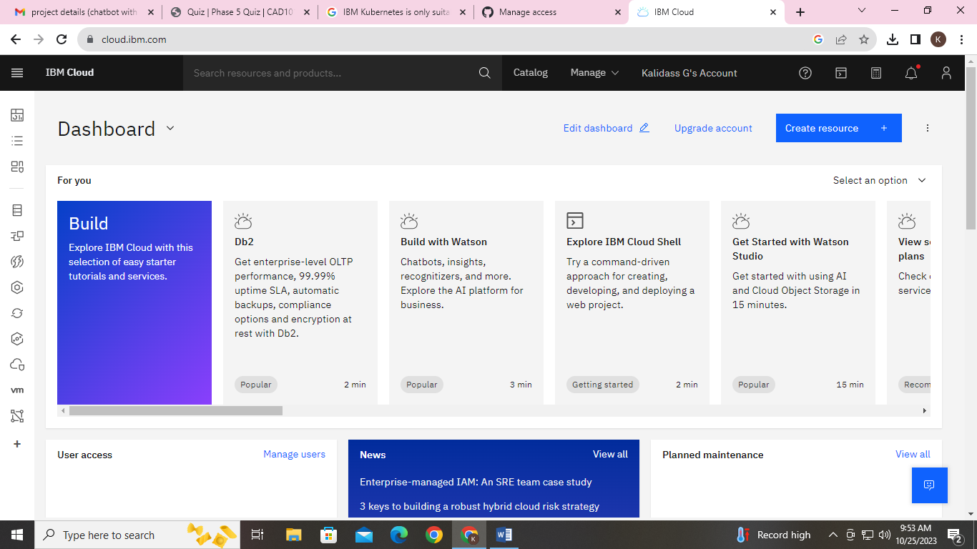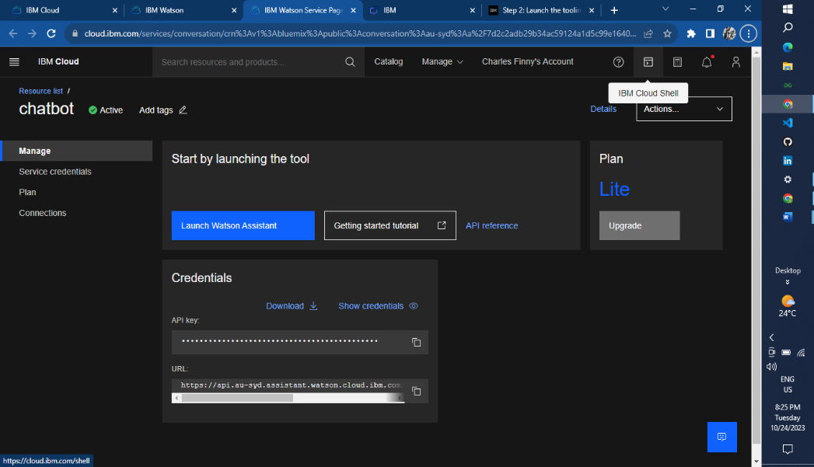

**Intents and Entities**

1. Greeting
2. Frequently asked questions
3. Password reset
4. Forgot password
5. Two-step verification
6. Add e-mail id
7. How to change profile settings
8. Account visibility
9. How to create a channel
10. How to edit connective peoples
11. Creating a new account
12. Deleting an account

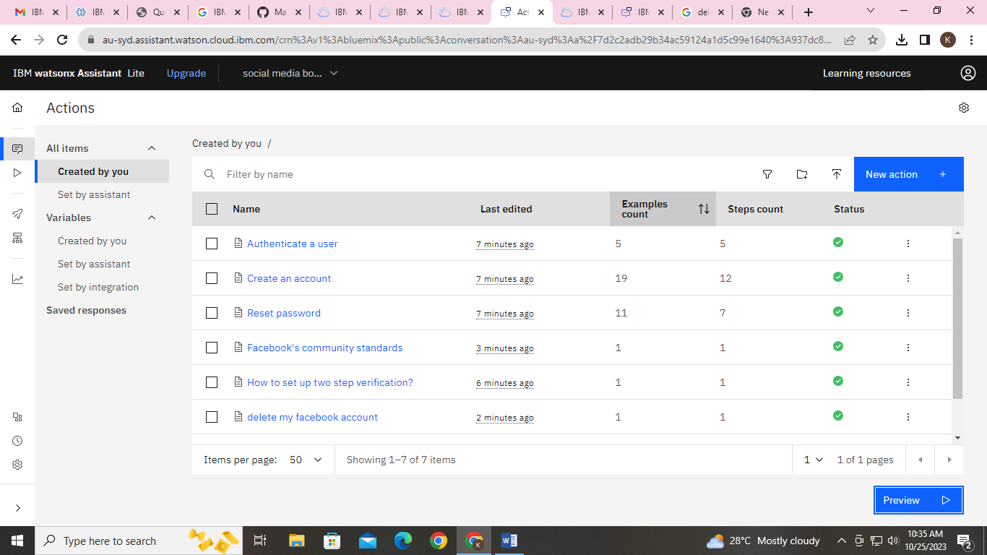

**Response code for a chatbot**

The code is **no need** to be used in Simple Watson Assistant Chatbot the process will done by the actions itself.

For our easy identification the JSON code as follows

Greeting: Hello! How can I help you today? ,

Common queries:

Query1: What are the supported file formats for profile pictures? ,

Answer: You can upload profile pictures in formats like JPEG, PNG, and GIF.

Query2: How to set up two step verification? ,

Answer: tap Settings > Scroll down and tap Password and security> tap Use two-factor authentication. [You may be asked to enter your password at this point.]

Query 3: How can I change my password? ,

Answer: To change your password, go to Settings > Security and Login > Change Password.

Query 4: How do I recover a hacked account? ,

Answer: If your account is hacked, visit the Help Center for steps on account recovery.

Query5: How can I report a post or user? ,

Answer: To report a post or user, click on the three dots (...) on the post and select 'Find support or report profile.' Follow the prompts to report the issue.

Query6: How do I enable two-factor authentication? ,

Answer: You can enable two-factor authentication by going to Settings > Security and Login > Use two-factor authentication.

Query7: How can I create a Facebook Page? ,

Answer: To create a Page, click on the '+' sign at the top right of your Facebook account and select 'Page.' Follow the steps to set up your Page.

Query8: What are Facebook's community standards? ,

Answer: Facebook's community standards outline the rules and guidelines for using the platform. You can find them in the Help Center.

Query9: how to delete my Facebook account? ,

Answer: tap Settings & privacy, then tap Settings > Personal and account information> Account ownership and control > Deactivation and deletion.

Fallback: I'm sorry, I couldn't understand your query. Please feel free to ask again or type 'help' for more options.

Like as the response configuration of the chatbot.

**Greeting message**

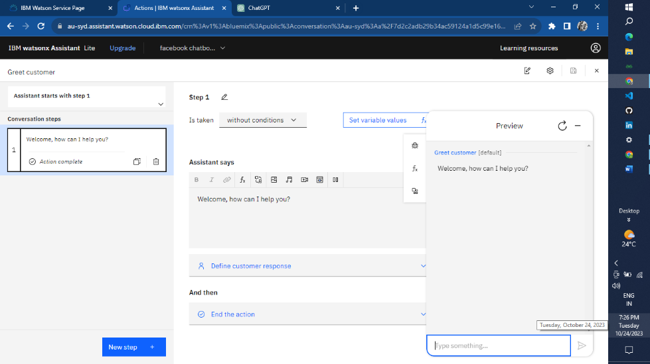

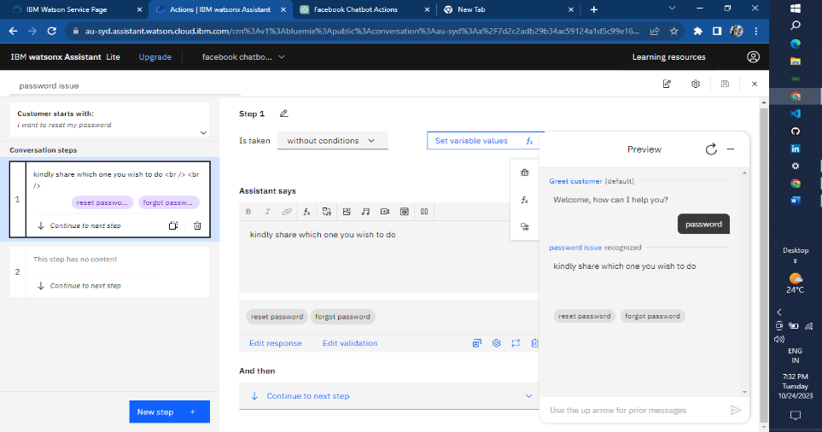

**Password Reset**

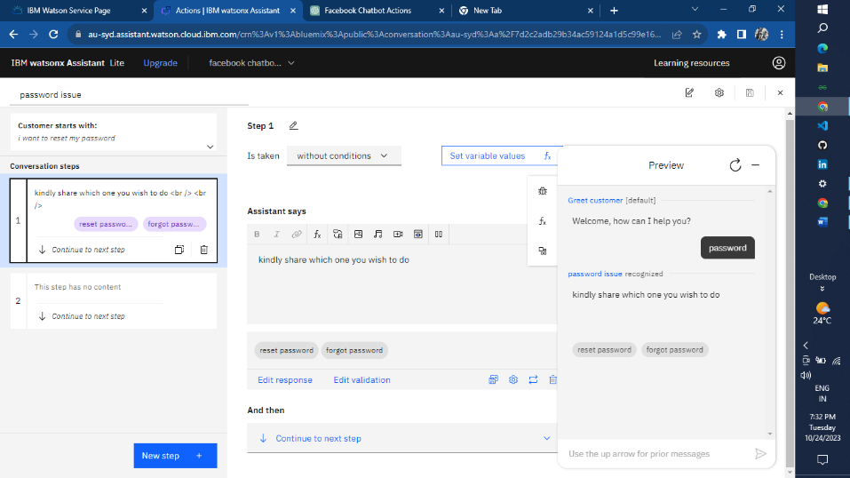

**Creating Facebook account**

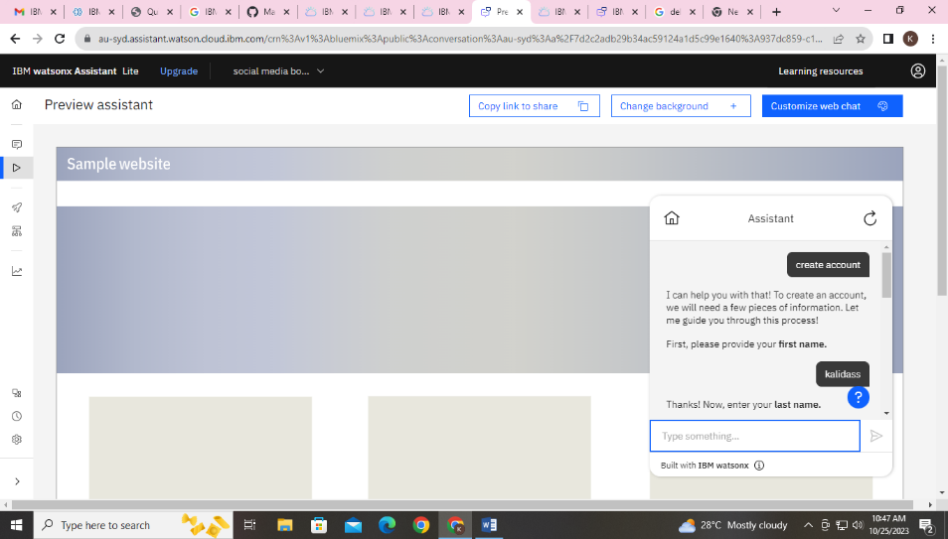

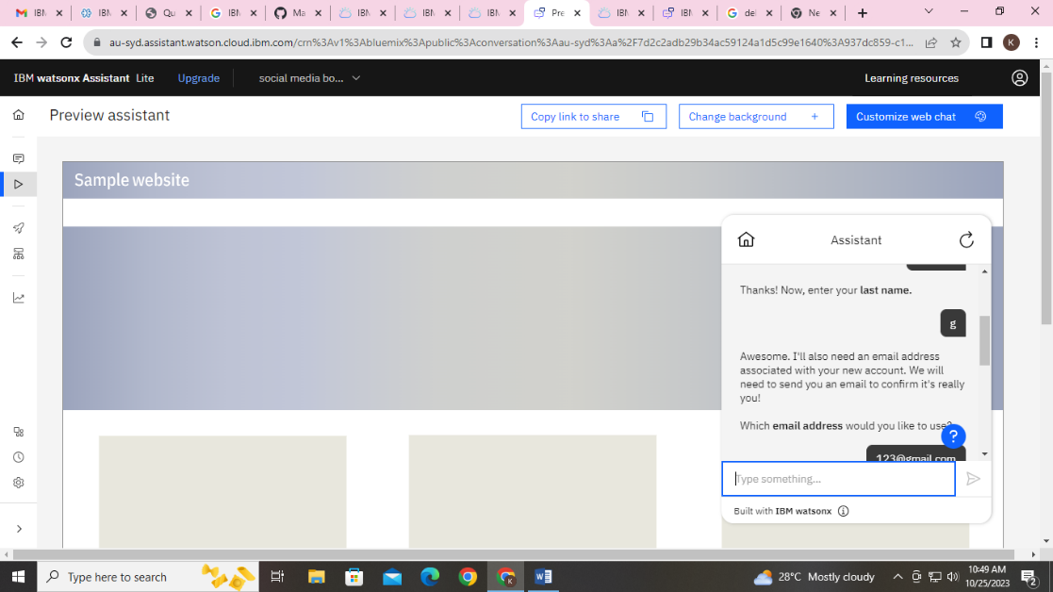

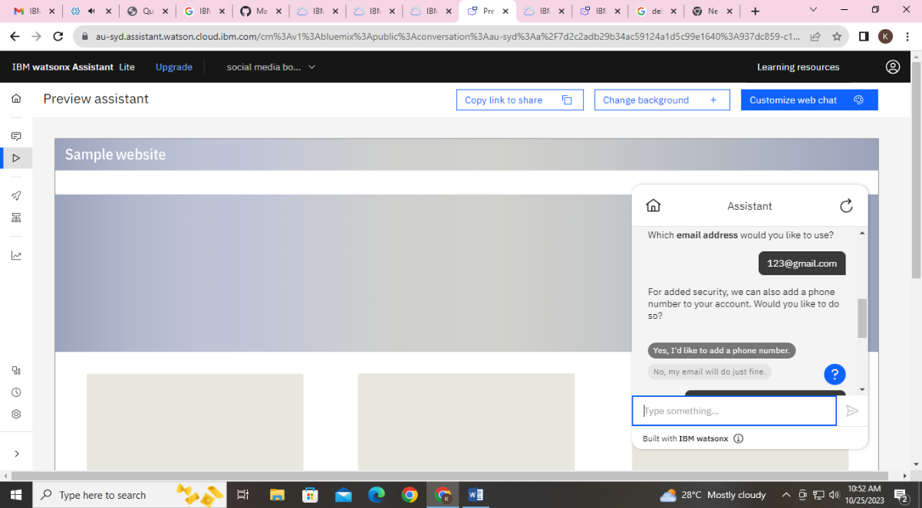

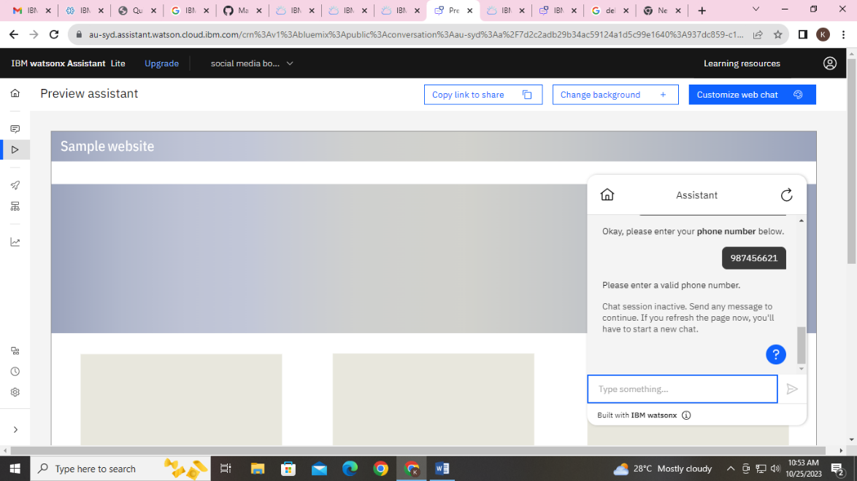

**Frequently asked questions**

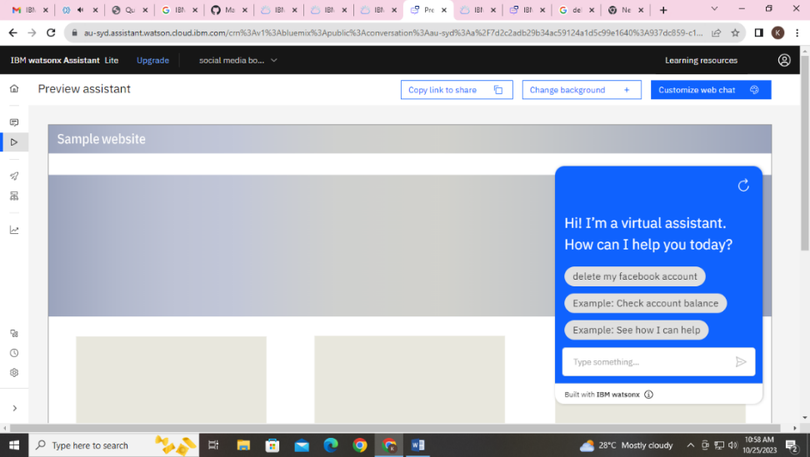

**Development Part -2**

In this phase we add more intents and entities to make the response of the Chabot as much as better.

**Continue Building and Refining responses:**

**Continue Building:**

We make our chatbot to response only for the Facebook messenger queries.

Now, we will also make the chatbot to respond in the slack application user queries also.

**Intents and Entities**

The several entities created for the slack application queries are as follows:-

1. Greeting message
2. Account creation
3. Payment options
4. Premium features
5. Creating a channel
6. Joining a channel
7. Share a file
8. Workflow builder
9. Record video and audio
10. Privacy settings

**Some of the chatbot responses**

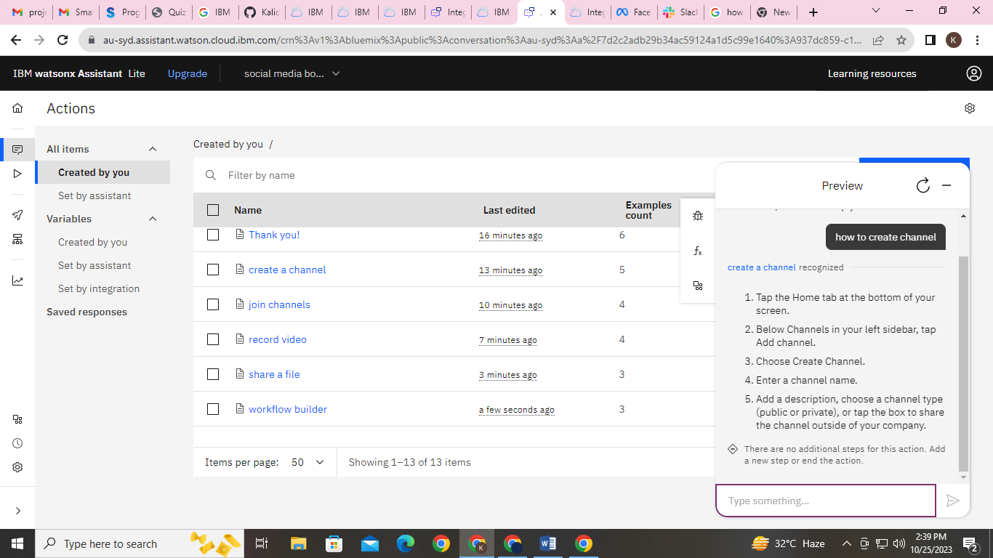 **Creating a channel**

**How to open workflow builder**

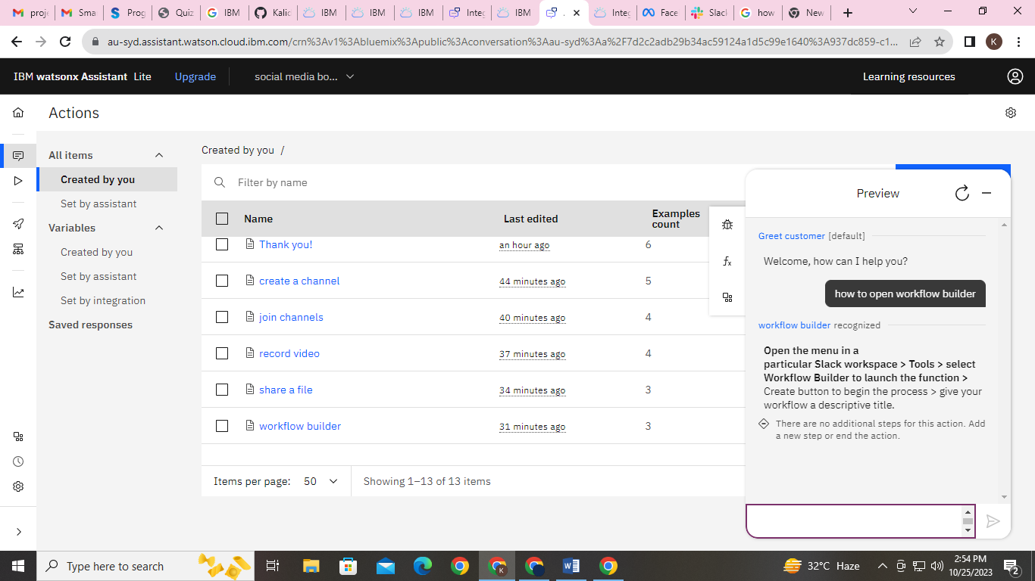

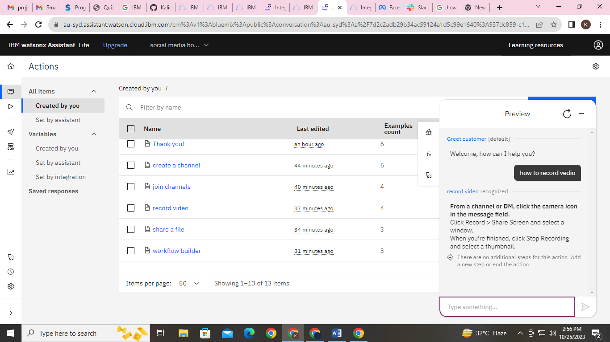**How to record video while sharing**

**Refining Responses:-**

Using the keyword recognition and more than 1 or 2 phrases for an single action to make the response as accurate to solve the query.

Example:-

Action:- Recording

Phrases: - 1.How to record a video?

2. How to record while in a call?

3. How to save my screen play?

4. How to enable recording?

5. Where is the Recording option?

**PLATFORM INTEGRATION:-**

We will integrate the chatbot with Facebook Messenger and Slack using respective APIs.

**Integration with FACEBOOK and SLACK :-**

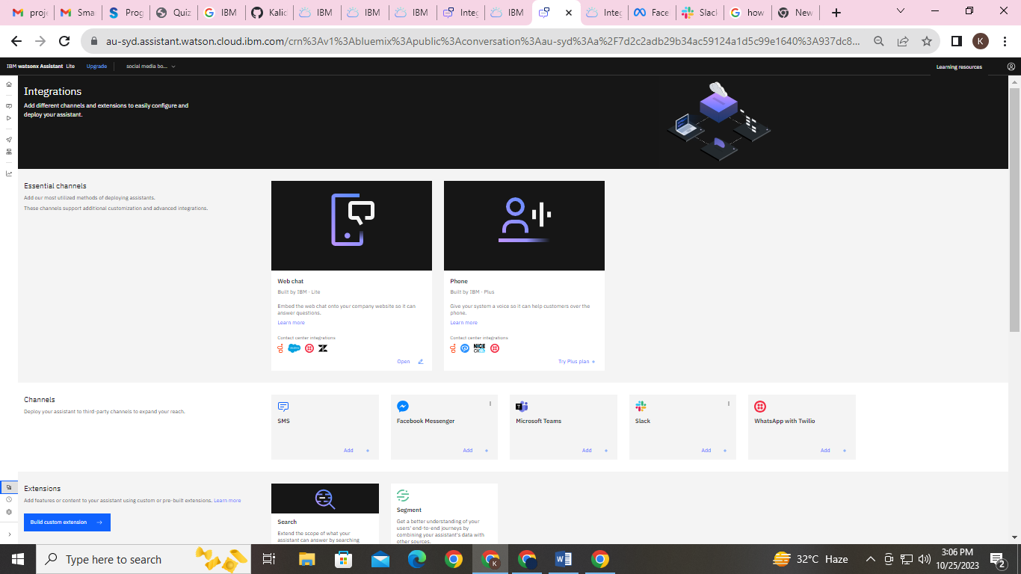

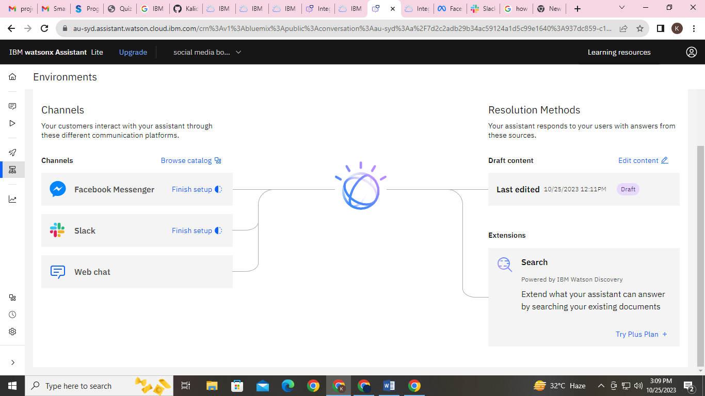

**Integration Chatbot in Facebook**

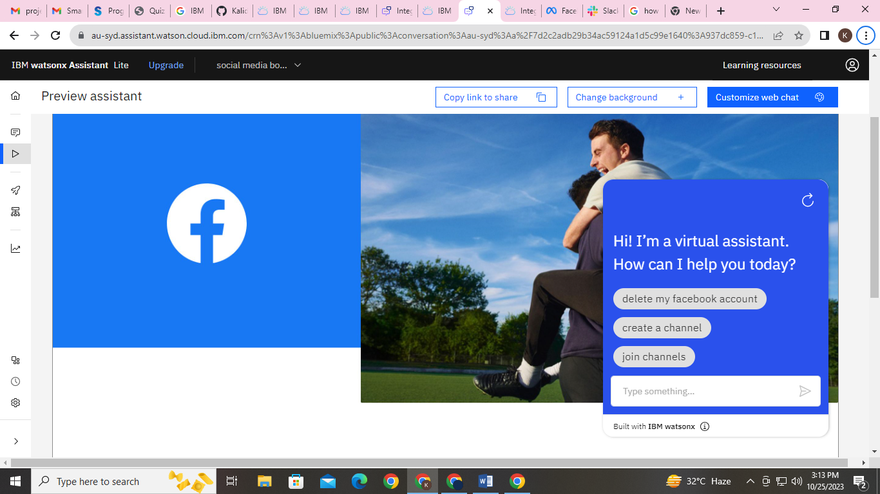

**Integration Chatbot in Slack:-**

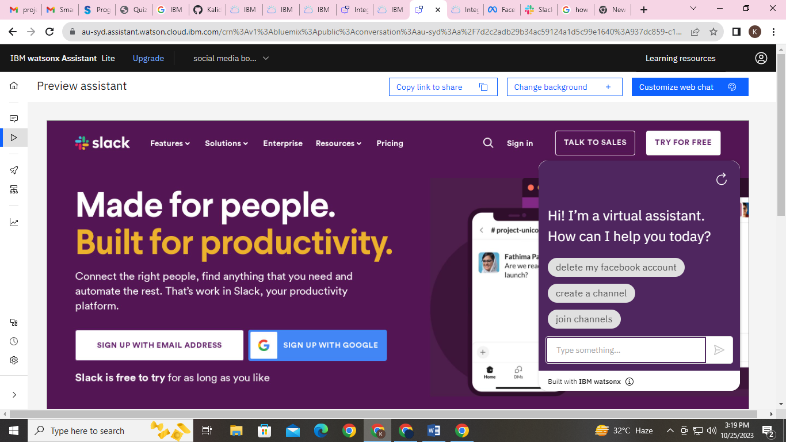

**User Experience:-**

We must make ensure that the conversation flows naturally and that the Chabot’s responses are informative and accurate.

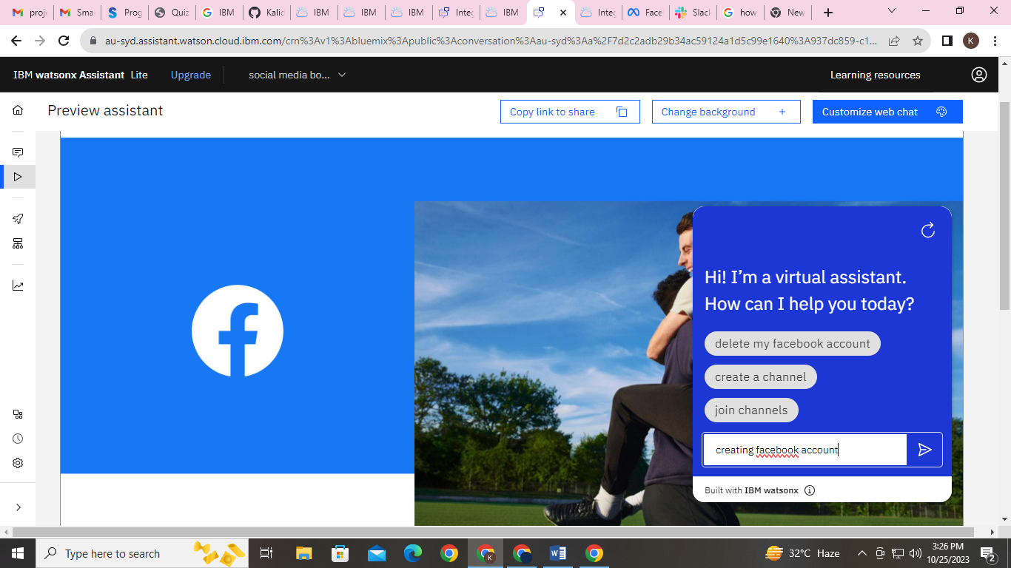 Let we check with one action as follows(previewing):-

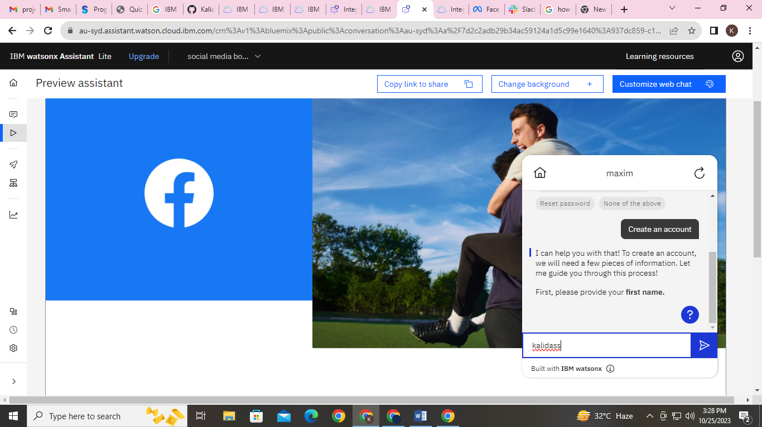

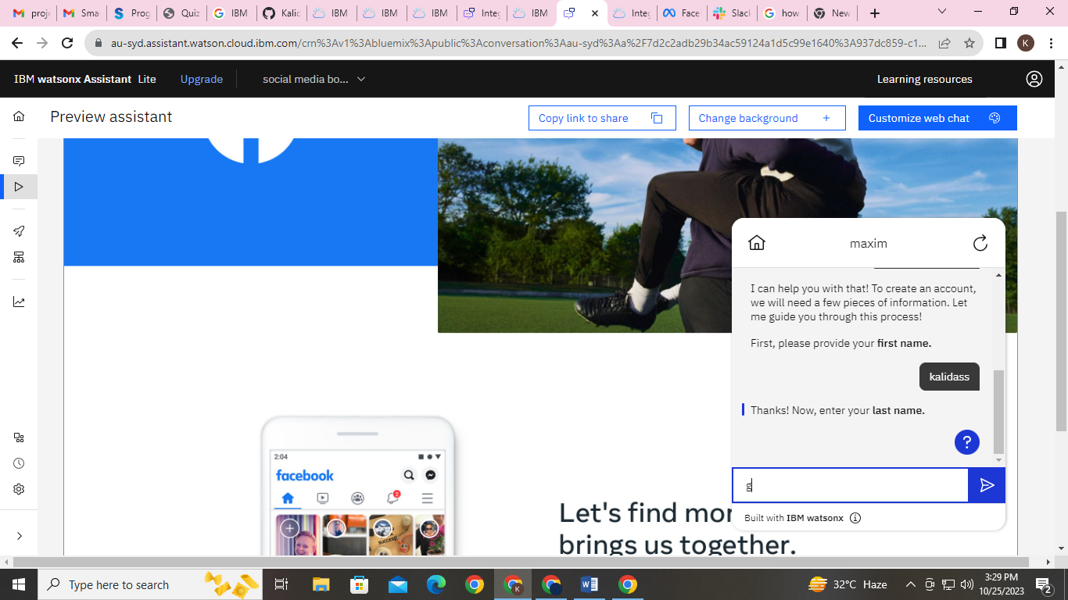

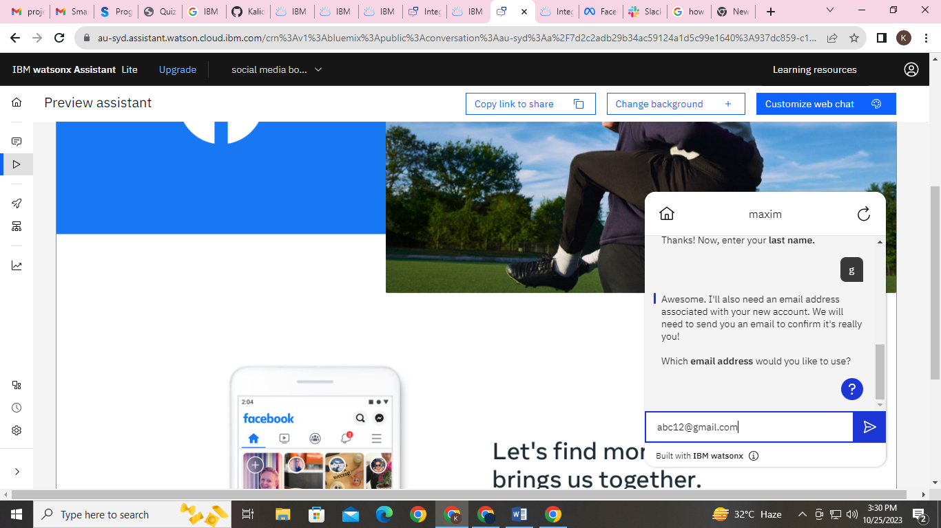

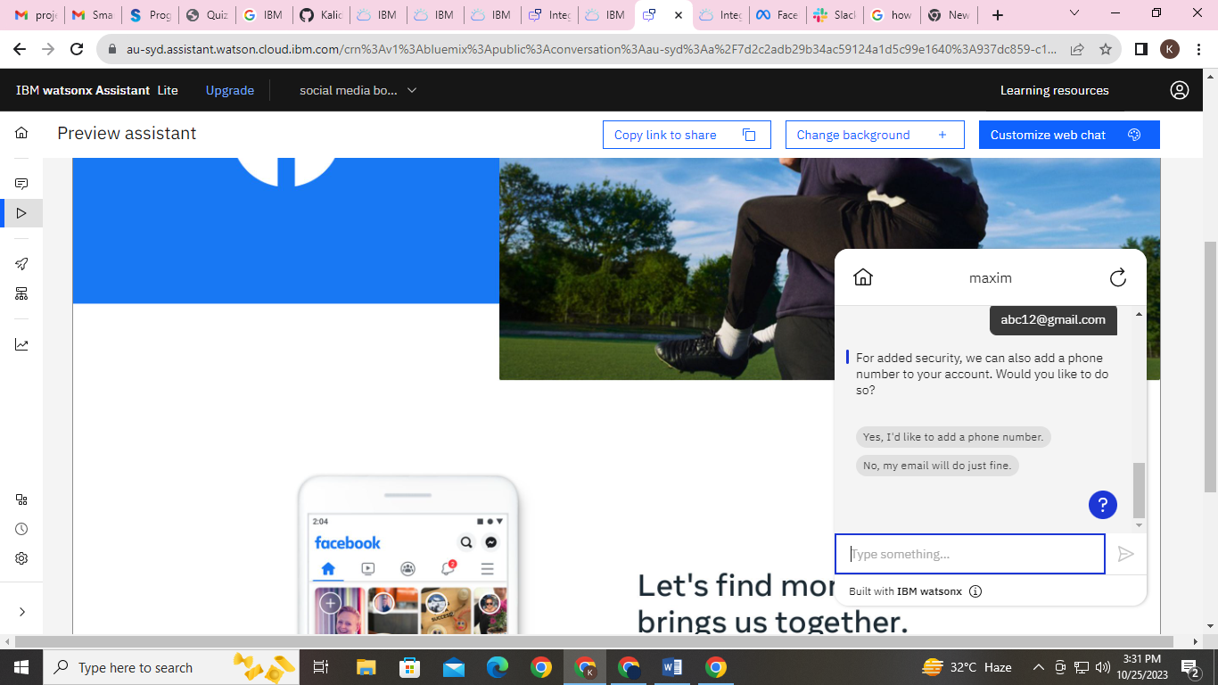

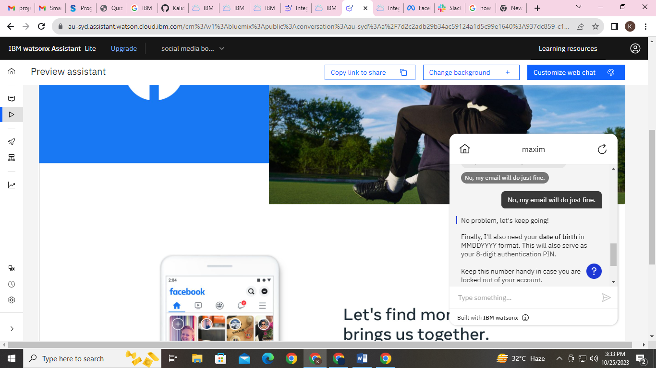

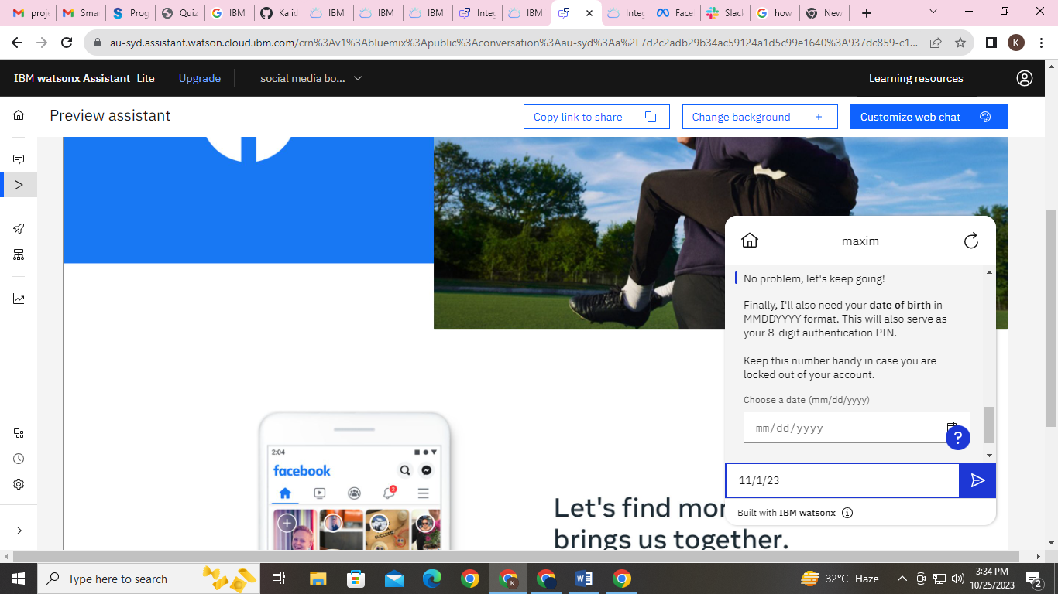

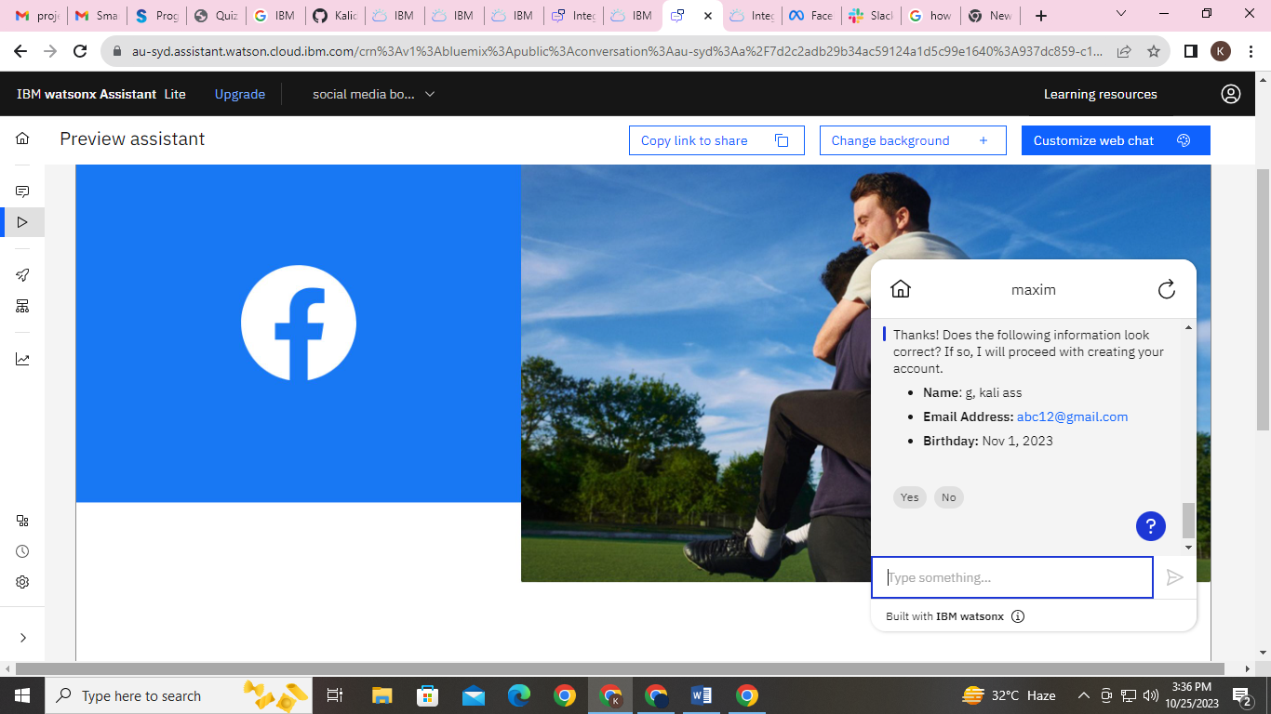

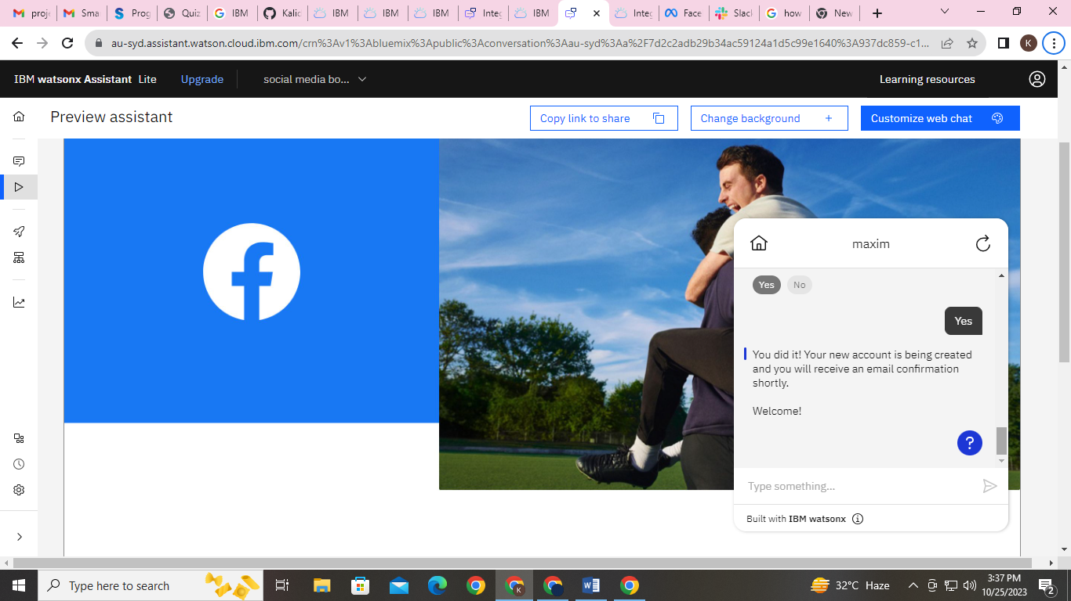

In the above response of the Chatbot for creating an account is user friendly and the conversation flow is very naturally.

It will be more informative to the first users as well as existing users.

**Conclusion:**

In this solution, we successfully deployed a chatbot using IBM Cloud Watson Assistant. By

Following the problem definition, design thinking, development, and documentation phases,

We designed and implemented a virtual guide that assists users on messaging platforms.

The chatbot provides helpful information, answers FAQs, and offers a friendly conversational

Experience. Through the integration with platforms like Facebook Messenger and Slack, we

Empower users with quick access to information and create meaningful connections through

the virtual guide.